**Muscular System Webquest**

Instructions: Follow the links provided to answer the following questions with **as much detail as possible**. Go to my website to find a link to this document so you can just click the links instead of typing them in.

**Step 1:** Go to <http://www.kidshealth.org/kid/htbw/muscles.html>

1. How many muscles are in the human body?
2. What are some examples of functions of your muscles?
3. What are muscles made of?
4. What are the 3 types of muscles?
5. What is the difference between voluntary and involuntary control of muscles?
6. What are smooth muscles? Where are they found? What do they do in these areas? Are they under voluntary or involuntary control?
7. What are cardiac muscles? What is the scientific name for these muscles? Where are they found? What do they do in these areas? Are they under voluntary or involuntary control?
8. What are skeletal muscles? What is another name for these types of muscles? Why do scientists use this name “striated”? Where are they found? What do they do in these areas? Are they under voluntary or involuntary control?
9. What do tendons do?
10. What are some of our most powerful skeletal muscles that help us maintain proper posture when standing upright?
11. Where do facial muscles attach?
12. Because of this, what do facial muscles allow us to do?
13. Name the muscle that’s attached only at one end. What does this muscle allow us to do?
14. List the 6 major types of muscles found on page 3, and where we can find each of these on the human body.

**Step 2:** Go to <http://www.kidport.com/Grade6/Science/BodyMuscles.htm>

**Take the quiz** and list below both the common and scientific (if given) names for each of the muscles listed:

|  |  |
| --- | --- |
| Common Name | Scientific Name (if given) |
| Neck Muscles |  |
| Shoulder Muscles |  |
| Chest muscles |  |
| Biceps |  |
| Triceps |  |
| Stomach Muscles |  |
| Thigh Muscles |  |
| Calf Muscles |  |

**Step 3:** Go to <http://www.bbc.co.uk/science/humanbody/body/factfiles/muscle_anatomy.shtml>

At the **bottom** of the page there is a link that says, **“FLEX SOME MUSCLES”**. 1) Click on this link and choose your gender. 2) Click on the muscles in the box on the **left**. **Read the description of this muscle in the box on the right**. 3) Click on the muscles on the right and **drag it** to the human body at the appropriate location. 4) Write down the **name** of each muscle (or muscular system related component), and it’s **common name location** on the chart below, then 5) have Mr. Tran check your diagram when it is complete. **Be sure to watch the animation for each muscle and what motion results**.

Note: the muscles are **randomly** generated, so **each** student should have **different** answers to the questions below!

|  |  |  |
| --- | --- | --- |
| Name of Muscle or Tendon | Common Name Location | What does this move? |
| 1) |  |  |
| 2) |  |  |
| 3) |  |  |
| 4) |  |  |
| 5) |  |  |
| 6) |  |  |
| 7) |  |  |
| 8) |  |  |
| 9) |  |  |
| 10) |  |  |

**Step 4:** Visit <http://www.sport-fitness-advisor.com/muscular-system-picture.html>

Label the following muscles on your diagram below:

Sternocleidomastoid, Trapezius, Deltoid, Pectoralis major, Latissimus dorsi, Biceps brachii, Aponeurosis, Transversus abdominus, Rectus abdominus, Internal/external oblique, frontalis, temporalis, flexor carpi radialis, rectus femoris + vastus muscles (quadriceps group), tibialis anterior, and peroneus longus

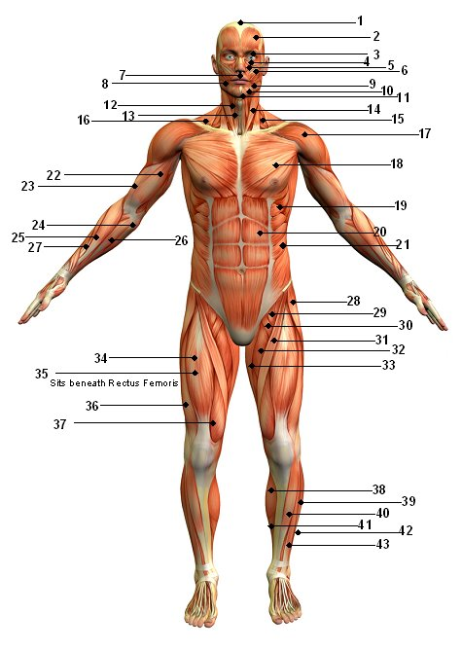

Visit <http://www.sport-fitness-advisor.com/muscular-system-diagram.html>

Label the following muscles on your diagram below:

Sternocleidomastoid, Trapezius, Deltoid, Latissimus dorsi, Triceps brachii, Gluteus medius, Gluteus maximus, Adductor magnus, Biceps femoris, Gastronemius

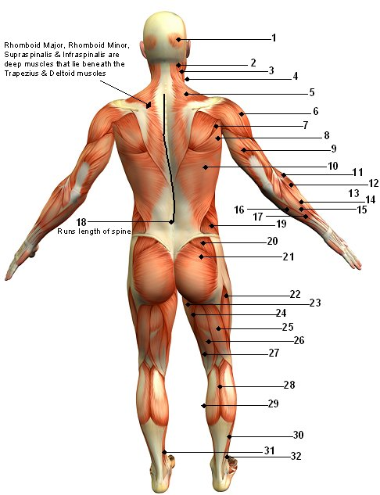

**Step 5:** Visit <http://www.gwc.maricopa.edu/class/bio201/muscle/mustut.htm>

Locate each of the muscles you have listed so far on this webquest.

**Step 6:** Visit <http://cwx.prenhall.com/bookbind/pubbooks/martinidemo/chapter11/medialib/CH11/html/ch11_3_3.html>

1. How do we name muscles?

2. What does “rectus” mean? What direction do these muscles tend to run?

**3. Copy and paste figure 11.1 here**

4. What do the following terms mean?

Longus

Longissimus

Teres

Brevis

Magnus

Major

Maxiumus

Minor

Minimus