Evolution Study Guide
Chapter 22
- Explain Darwin’s Theory of Evolution….Essay!!!
- How was the theory of evolution different than the prevailing theories of the time?
- Understand Lamarck’s theory and why it was wrong.
- What were Cuvier’s beliefs on extinction and evolution.
- Where would closely related species be located with respect to layers in sedimentary rock
- What is artificial selection? Give examples.
- What must be true for evolution to occur? (at least 2 things)
- What did Malthus contribute to the theory of evolution?
- What are homologous structures? Know examples.
- What are analogous structures? Know examples.
- What is one of the strongest pieces of evidence for a common origin of all life on Earth?
Chapter 23
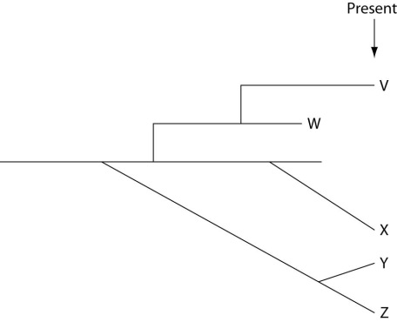
- Read a phylogenic tree and make conclusions:
- Figure out allele frequencies using Hardy-Weinberg
- What is the difference between genetic bottleneck and founder effect? What effects do they have on the genetics of a population?
Chapter 24
- Know the difference between allopatric and sympatric speciation.
- Know the different types of selection and know examples of each.
- Know the different types of isolation and examples of each.
- Understand why many hybrids do not become a species.
- What is the difference between gradualism and punctuated equilibrium?
Chapter 25
- What do all cells including the first have in common?
- What was the first genetic material on Earth?
- What was the condition of Earth’s atmosphere 3 billion years ago?
- Use carbon dating to find the age of a fossil.
- Know the role of ancient cyanobacteria
- Sequence of development from bacteria to multicellular life.
- What is the importance of Hox genes?
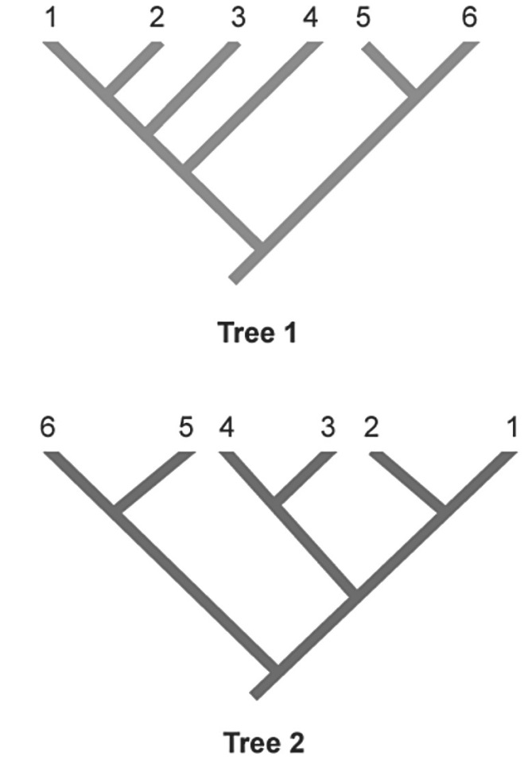
- What is adaptive radiation?
Chapter 26
- Draw conclusions based on these trees
- What is the difference between phylogeny and taxonomy?
- And this trees

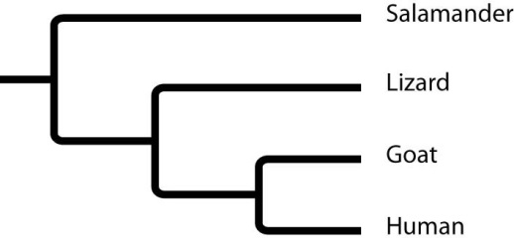

- What is convergent evolution? Give examples.
- What would it mean to apply parsimony to a phylogenic tree?
- What is an outgroup in terms of building a phylogenic tree? (much easier than you think, think of sesame street)
- What is endosymbiosis?

