Chapter 8
- What is the definition of metabolism?
- What are examples of potential and kinetic energy?
- What is the difference between catabolism and anabolism? (include how they change the entropy within a cell)
- What are the first and second laws of thermodynamics?
- What is the Gibb’s free energy equation and what do the parts stand for? What does a positive or negative result mean?
- What is the difference between exergonic and endergonic reactions?
- What happens to the heat produced by an organism?
- What is the lock and key model for enzymes?
- What do cofactors and coenzymes do?
- What are the types of inhibitors and how do they work? (or not work…nerd joke)
- 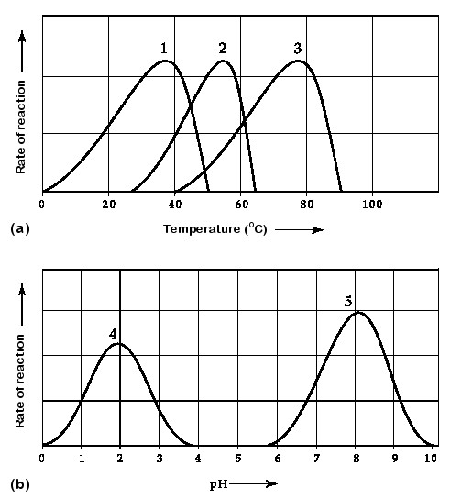

Chapter 9
- What is the equation for cellular respiration? What is oxidized and what is reduced?
- When NAD+ is turned into NADH is it reduced or oxidized?
- What is the role of oxygen at the end of ETC?
- What are the net products of glycolysis?
- What releases the most CO2 during aerobic respiration? Where else is CO2 released?
- What are the electron carriers of the citric acid cycle?
- 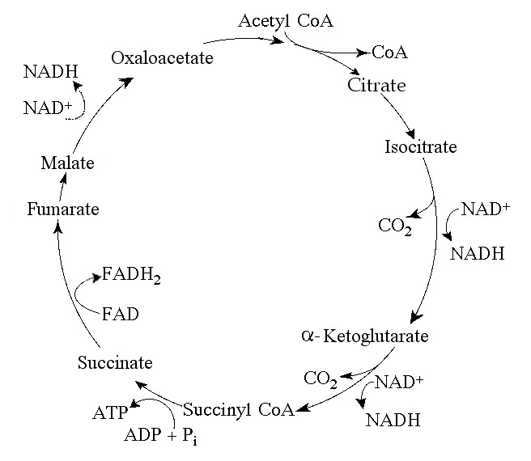
- What takes place in the ETC?
- During aerobic respiration, electrons travel from ___________to ______________to _______________to ________________
- Where is the ETC located?
- About how many ATP are produced through Aerobic respiration?
- Where does glycolysis occur?
- What process occurs with or without o2
- What is the purpose of fermentation?
- Where does CO2 come from?

Chapter 10
- What wavelengths of light are most effective for photosynthesis?
- What event accompanies energy absorption by chlorophyll (or other pigment molecules of the antenna complex)?
- Where does photosystem II get its electrons?
- What process splits CO2 into carbon compounds?
- What process produces O2?
- What does the Calvin Cycle need in order to run? (attained from light reactions)
- Where does the Calvin Cycle take place?
- What is the function of the Calvin Cycle?
- List things that occur in the Calvin Cycle?
- What is the value of ΔG if ΔH = -32.0 kJ, ΔS = +25.0 kJ/K and T = 293 K? ____________
- Is the reaction in Problem 36 spontaneous? __________________
- What is the value of ΔG if ΔH = +12.0 kJ, ΔS = -5.00 kJ/K and T = 290. K? ____________
- Is the reaction in Problem 38 spontaneous? ___________

- 