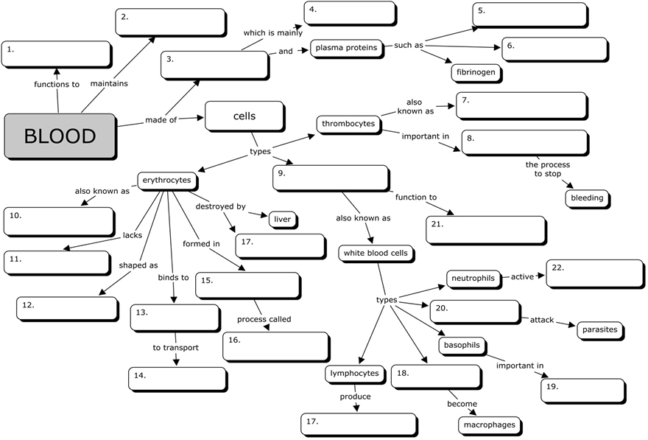
WORD BANK
red blood cells | homeostasis | albumins |biconcave disc | bone marrow | transport nutrients | hemoglobin | monocytes | defend against diseases | plasma | leukocytes | spleen | phagocytes | inflammatory reaction | water | platelets | hematopoeisis | eosinophils | oxygen | nucleus | hemostasis | globulins | antibodies

